16th April 2013

**YOKOHAMA Develops New Inner Liner Technology for Commercial Vehicle Tyres**

***Substantially Reduces Natural Air Leakage***

Tokyo - The YOKOHAMA Rubber Co., Ltd., announced today that it has developed new inner liner technology that substantially improves the ability to maintain air pressure in commercial vehicle tyres for trucks and buses. The new inner liner can reduce natural air leakage by about 30%* compared with conventional liners, helping maintain tyre pressure and allowing the design and manufacturing of lighter tyres. The new inner liner technology is being applied to tyres manufactured at domestic plants from April 2013, and will gradually be introduced at plants overseas.

Inner liners are rubber sheets covering the interior surfaces of tubeless tyres to reduce air leakage from the tyre. YOKOHAMA’s new inner liner uses “flat talc” – particulate talc in planar shapes, a key characteristic of the mineral talc – imbedded in the rubber in multiple layers. The flat talc blocks the permeation of air through the rubber, substantially cutting the volume of air naturally escaping from the tyre.

Under-inflation of a tyre not only reduces fuel efficiency due to increased rolling resistance, but adversely affects wear and safety. For those reasons, YOKOHAMA has been engaged in research and development of inner liner technology to reduce air leakage. In 2009, it released its “AIRTEX Advanced Liner,” created from new materials, for passenger cars, and has employed in fuel-efficient tyres and comfort tyres.

*Detailed test results are on file with the Tyre Fair Trade Council in Japan.

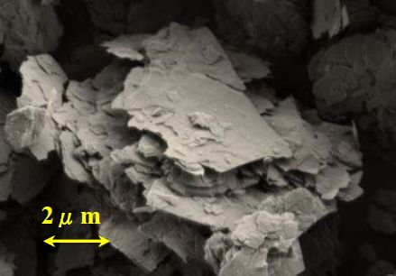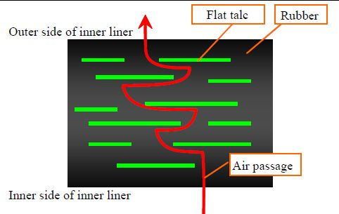

***Microphotograph of “flat talc” (10,000 times) How new inner liner reduces air permeation***